BinarX

Satnogs Ground Station Kit

High-Gain Antenna Instructions

This guide walks students through assembling their high-gain antennae, enabling them to listen to the entire radio spectrum and communicate with satellites in Low Earth Orbit (LEO).

The aim is to have the students assemble and test the antenna themselves, but support may be required for 3D printing and sawing.

|  |  |  |  |
| --- | --- | --- | --- |
| MISSION PHASE | SKILL AREA | AUDIENCE | LAST UPDATED |
| Phase |  | School Years 7-10 | 03/12/2024 |

**WARNINGS:**

Wear a mask and other appropriate protective equipment (safety glasses etc.) when cutting, drilling or sanding any materials, as they can emit small particles that may irritate your lungs, or eyes.

Sharp objects like razor blades, utility knives, or even the edges of the measuring tape can cause injury. Be very careful handling any sharp objects and the edges of the tape measure.

Soldering irons become VERYhot when turned on. Be careful not to touch the iron when it is on or cooling down. Solder also releases fumes when melted, even with lead-free solder. Make sure to use a fume extractor or wear appropriate protective equipment before attempting soldering.

Incorrectly connecting and disconnecting radio connectors may damage or break the connectors. Note that the instructions on how to correctly connect the radio connectors for this step and any following connections are written on Pages 12-13

**Setup Instructions**

**Parts Required:**

1. UHF Female Crimp Connector
2. RG58 Coaxial Cable (0.25m)
3. 5m Tape Measure (19mm Blade)
4. PVC Pipe (27mm Outer Diameter x 0.5m)
5. Insulating Tape / Electrical Tape
6. 3D Printed Grip or Handle
7. 3D Printed Element Brackets and Cap
8. 3D Printed Phone Clamp
9. Coaxial Cable Crimp Tool
10. Sandpaper
11. Soldering Iron and Lead-Free Solder

Note: If 3D printed pieces are too tight, sand the inside rings down until they fit and do not move around the pipe easily. If they are too loose, you may want to try adding some electrical tape to the pipe before sliding the bracket into place.

If the Nut does not screw onto the phone clamp easily, try to scale it up by 5-10% in the 3D printing slicer and try to print it again.

Step-by-Step Setup – Please have students do this themselves, with a potential exemption in sawing materials or soldering to steel (this can be quite tricky!)

1. **Cutting Drilling the PVC Pipe**
   1. Warning: Wear a mask and other appropriate protective equipment (safety glasses etc.) when cutting, drilling or sanding PVC pipe, as it can emit small particles that may irritate your lungs or eyes.
   2. Before you can begin assembling the antenna, you will need to get all the parts to build one. You can ask your teacher for some help sawing the PVC Pipe into the right size if it isn’t already.
   3. Mark the PVC pipe roughly 20.5cm from the one edge. Then mark the PVC pipe again, 70mm from the same edge, but on the opposite side, as shown from the side in the image below.

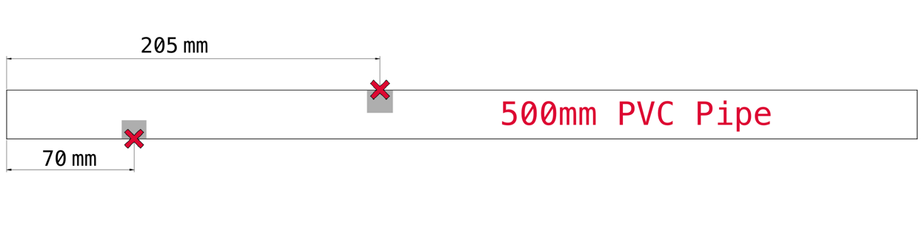

* 1. Using a drill and a 3/8” drill bit, drill the two holes through their side of the pipe so we can pass the coaxial cable through later.

1. **Measuring and Cutting the Tape Measure**
   1. Warning: Wear a mask and other appropriate protective equipment (safety glasses etc.) when cutting or sanding the tape measure, as it can emit small particles that may irritate your lungs or eyes.
   2. Use a screwdriver to unscrew the case around the measuring tape.
      * Note that this step should be done outside with lots of caution as the tape measure may rapidly extend and cause injury.
   3. Once the tape measure is fully extended, using scissors, cut the metal bracket at the front off so you have a straight edge.
   4. Using the tape measure markings, mark roughly 1.3m and using scissors, cut along a straight line perpendicular to the edge.
2. **Measuring and Cutting the Coaxial Cable**
   1. Using a ruler (or the measuring tape you now have), measure and mark 25cm on the coaxial cable.
   2. Use a pair of wire cutters to cut the cable to the measured length.
3. **Preparing the Antenna Elements**
   1. Warning: Sharp objects like razor blades, utility knives, or even the edges of the measuring tape can cause injury. Be very careful handling any sharp objects, and the edges of the tape measure.
   2. Using the following image as a reference, cut out all the lengths shown. In the end, you should have 5 separate cuttings and some left over tape measure. Note: there will be some left over tape measure.

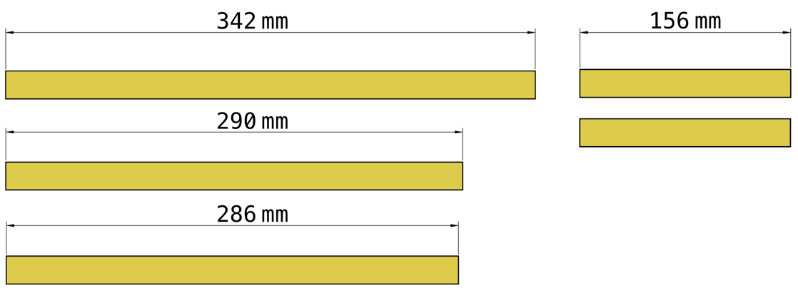

* 1. On the outwards curved edge of the two 156mm cutouts, using the sandpaper, sand approximately 2cm of the yellow paint off, leaving only the silver metal behind.
     + Note that it does not have to be perfect, but only enough to allow a good solder connection to be made.

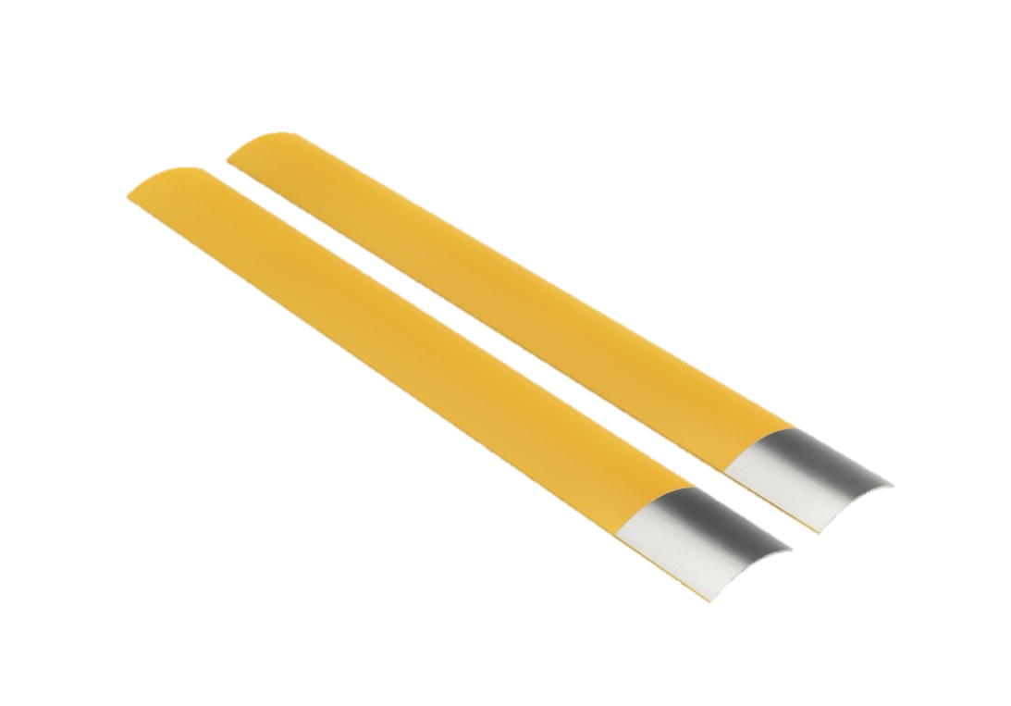

1. **Preparing the Coaxial Cable**
   1. Warning: Sharp objects like razor blades, utility knives, or even the edges of the measuring tape can cause injury. Be very careful handling any sharp objects, and the edges of the tape measure.
   2. To allow the connector to be placed on the cable, some careful cutting has to be done.
      * Using a utility knife, razor blade, or even a bit of the leftover tape measure, cut a straight line, roughly 3cm in length, along the black outer layer of one end of the coaxial cable.

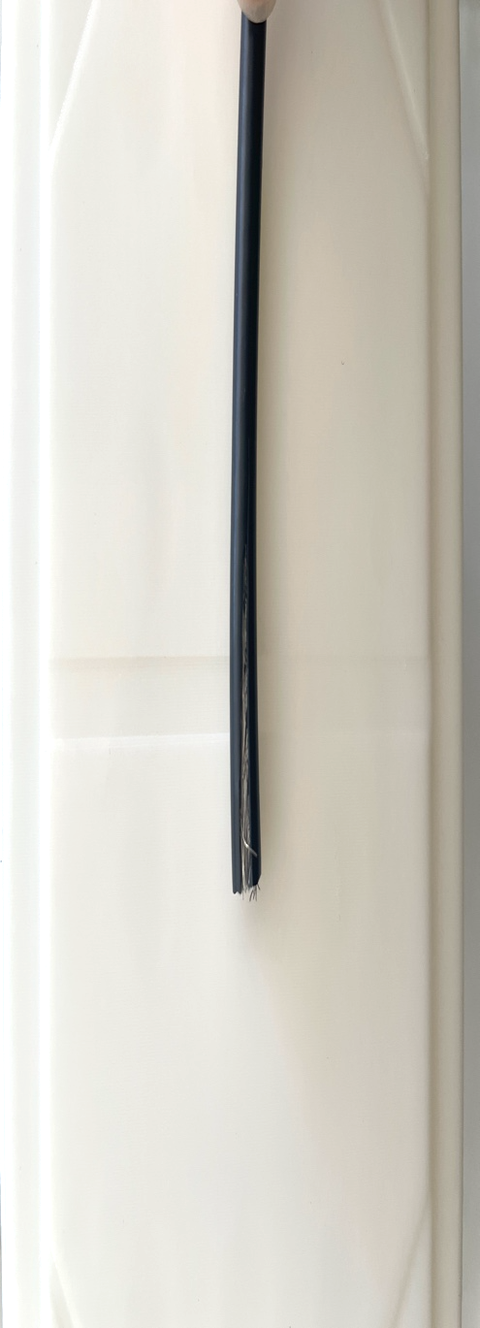

* + - Carefully peel this towards the other side so you can see the silver braids inside. Using scissors, cut the folded black layer off.

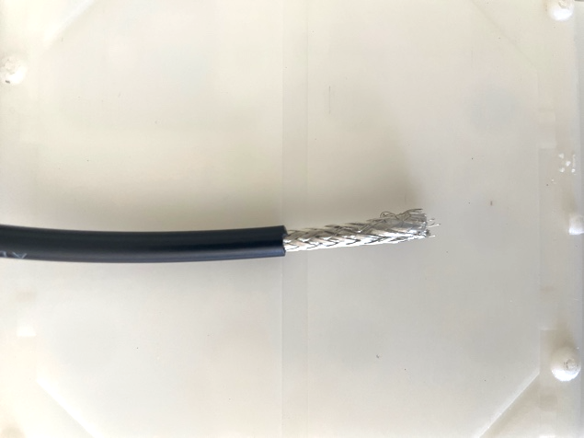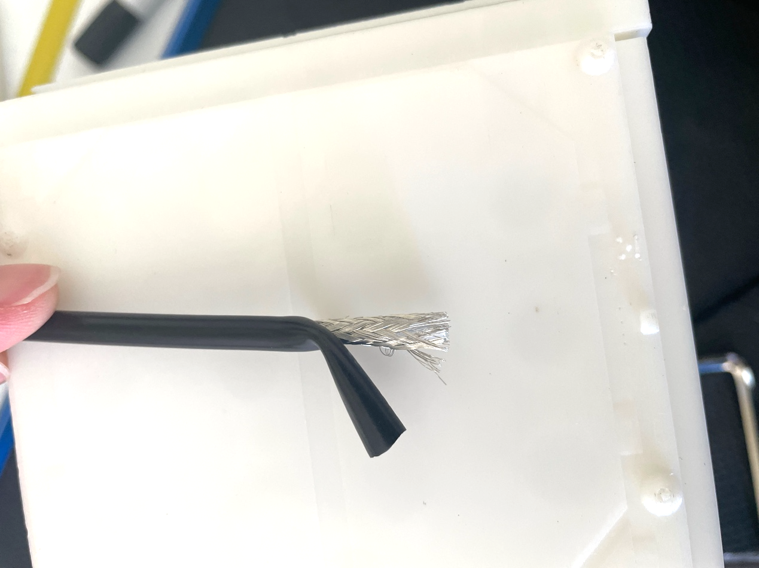

* + - Using your fingers, gently peel the silver braiding to one side, making sure all these wires are together. Twist them together to make one ‘larger’ wire.

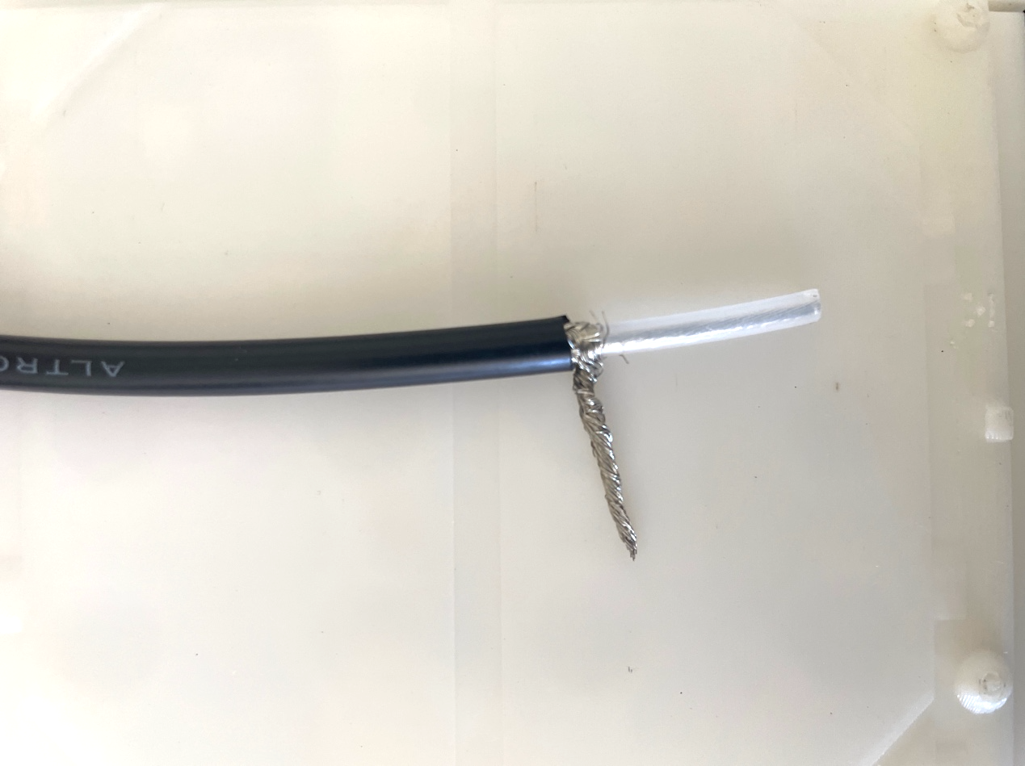

* + - Use the blade to carefully cut off 1.5cm of the material surrounding the inner wire, making sure that there is still enough left so the silver braids do not touch it, and the inner wires do not get cut.

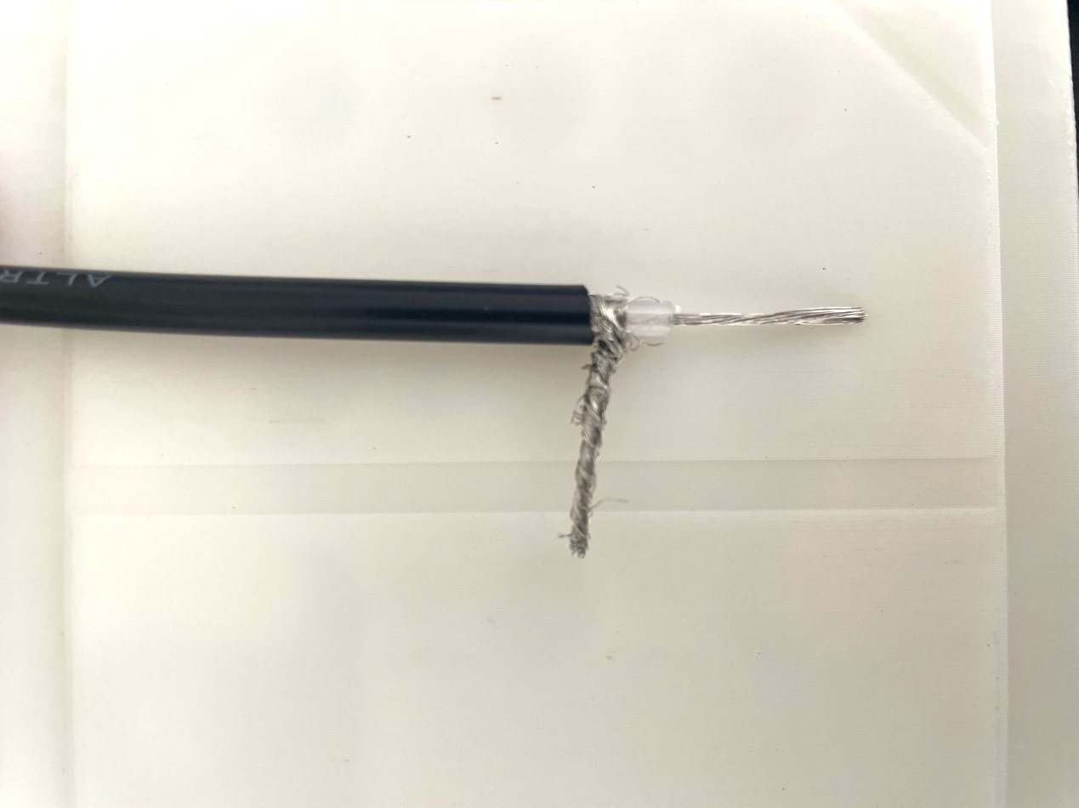

* 1. 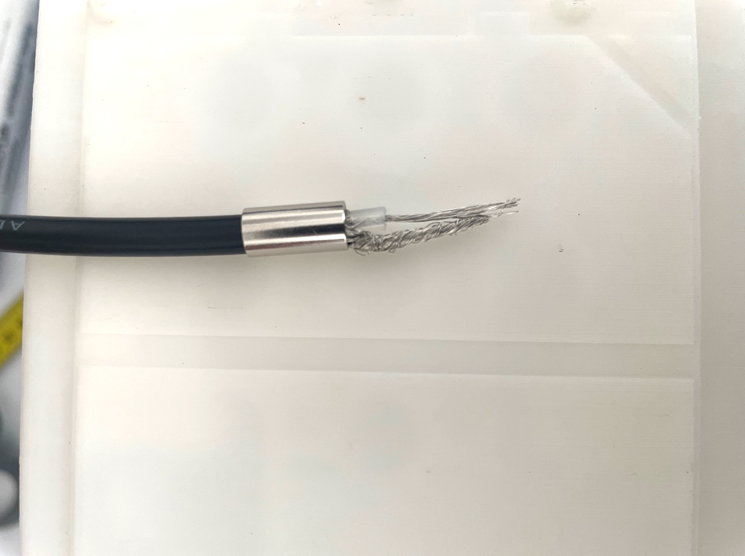You now have to place the connector onto the cable so it can connect to the antenna. Start by sliding on the larger hollow piece over the inner wire and silver outer wire so that it sits on the black insulation.
  2. Next, carefully place the inner wires inside of the small gold pin, twisting the wires if needed. Using a coaxial crimp tool and an appropriately sized hole, crimp this pin onto the inner wires.
  3. Then pass this pin and the inner wire through the hole on the bottom of the connector, making sure the silver wires stay on the outside.
  4. Slide the hollow part upwards so it completely covers the silver braids.
     + Note that this may take a bit of force.
  5. Using the coaxial crimp tool, place the part you have just moved in an appropriately sized hole. Squeeze down until it locks and releases. This should now stay in place.

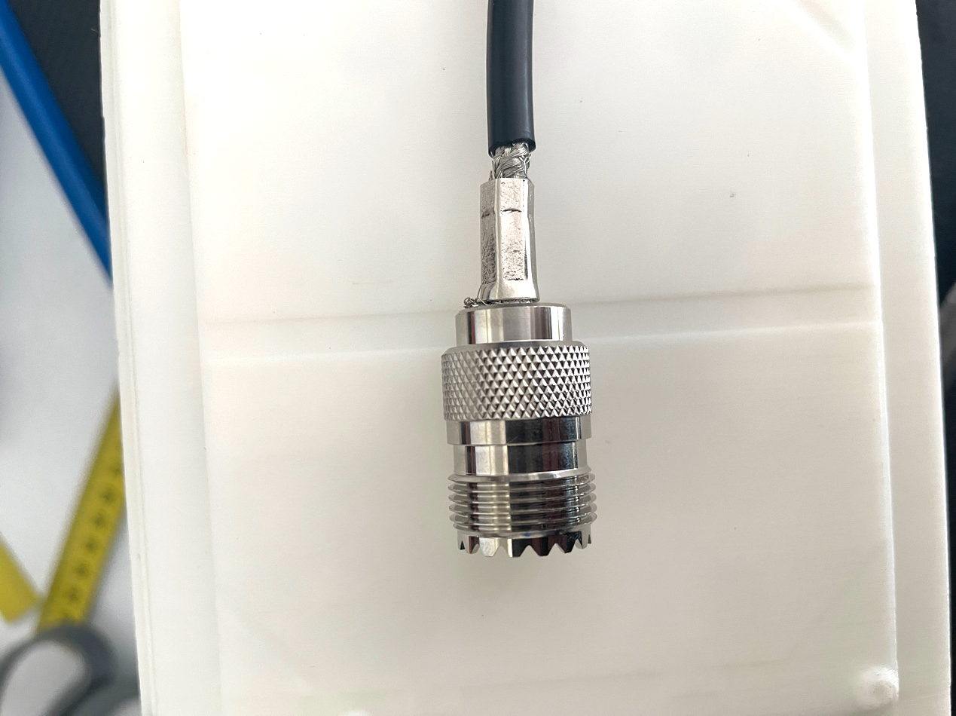

* 1. Using some insulating tape, cover any exposed cable left behind.
  2. Repeat Step b. again on the other side of the cable, leaving both sets of wires separated.

1. **Beginning to Put it All Together**
   1. Slide on the four 3D-printed element brackets so that there is one parasitic bracket before the hole on the shortest side, with the first bracket after the hole being the driven element bracket, as shown in the image below.

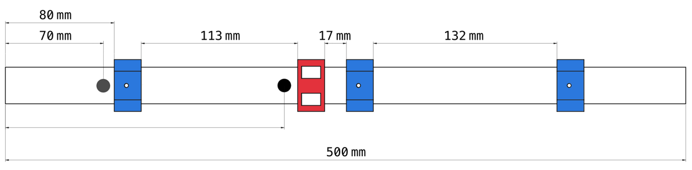

* 1. Using the two smallest elements (the ones that were sanded), slide them into the driven element bracket (as depicted by the red in the image above).
  2. Slide the coaxial cable through the PVC pipe up through the first hole at 70mm, pulling the side without the connector through the 205mm hole you had drilled earlier. This is shown through the blue line in the image below:

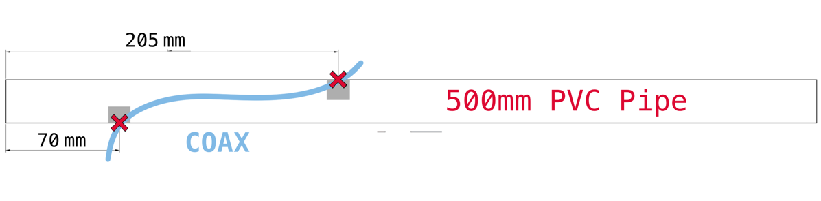

1. **Soldering the Driven Element**
   1. Move the inner wire of the coaxial cable towards one sanded metal pad on the tape measure and the silver braid outer wire towards the opposite sanded pad on the tape measure.
   2. Warning: Soldering irons become VERYhot when turned on. Be careful not to touch the iron when it is on or cooling down. Solder also releases fumes when melted, even with lead-free solder. Make sure to use a fume extractor or wear appropriate protective equipment before attempting soldering.
   3. Using a soldering iron and lead-free solder, carefully solder each to their respective pads. Make sure that no wires in the outer braids are touching the inner wire.

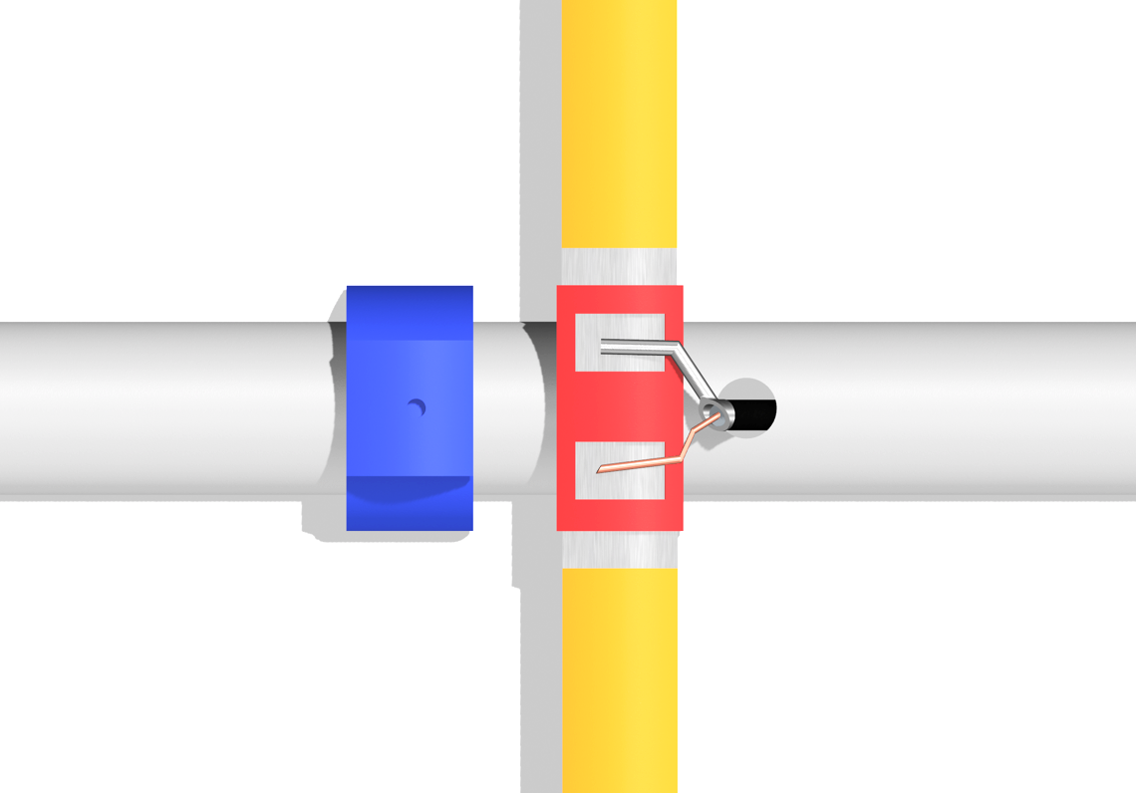

* 1. Cut a small length of electrical tape, roughly 5cm long and place it over the top of the connections to cover the solder connection. Use more, if necessary, to secure this covering, as shown below.

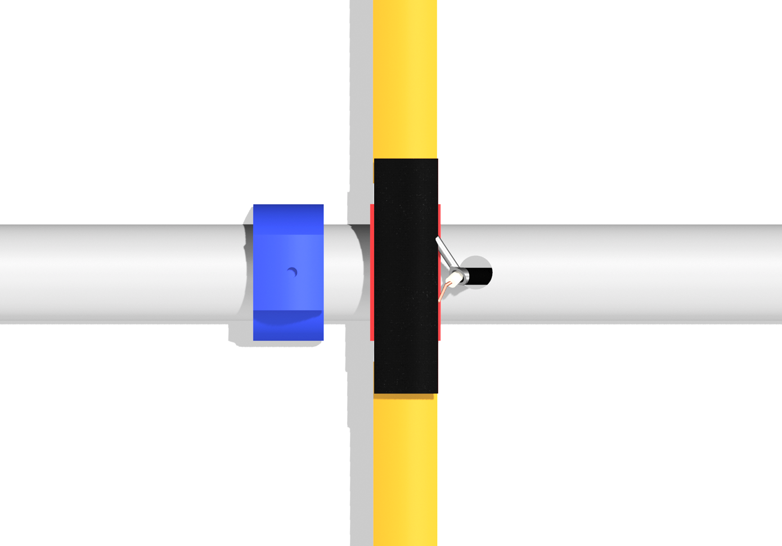

1. **Assembling the Antenna**
   1. Separate the remaining tape measure elements and organise them from longest to shortest.
   2. Using a ruler, roughly measure and mark the centre of each element with a ruler.
   3. Beginning with the longest element, slide it into the bracket closest to the short edge of the PVC Pipe past the hole, making sure you can see your marking through the hole.
   4. Using the next longest element, slide it in the bracket following the driven element, again making sure you can see the marking through the hole.
   5. Repeat this for the final shortest element.
2. **Finalising the Assembly**
   1. Before the antenna is finished, we have to add the phone clamp and grip to make it easier to hold and use.
   2. For the phone clamp, slide the main bracket on the side closest to the coaxial cable. Push this as far as you can without bending the coaxial cable at the bottom. Make sure the screw half faces upwards.

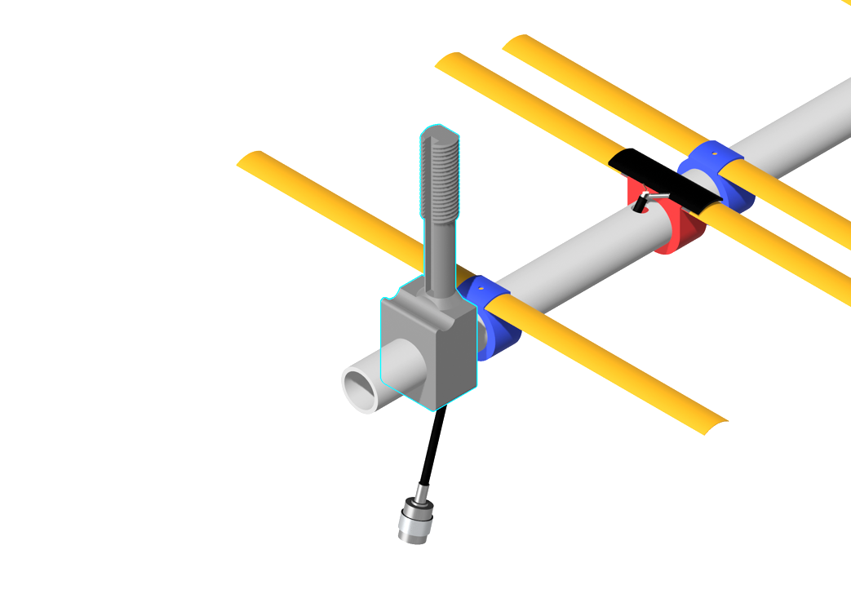

* 1. Place the top nut onto the top clamp element, as shown in the image below.

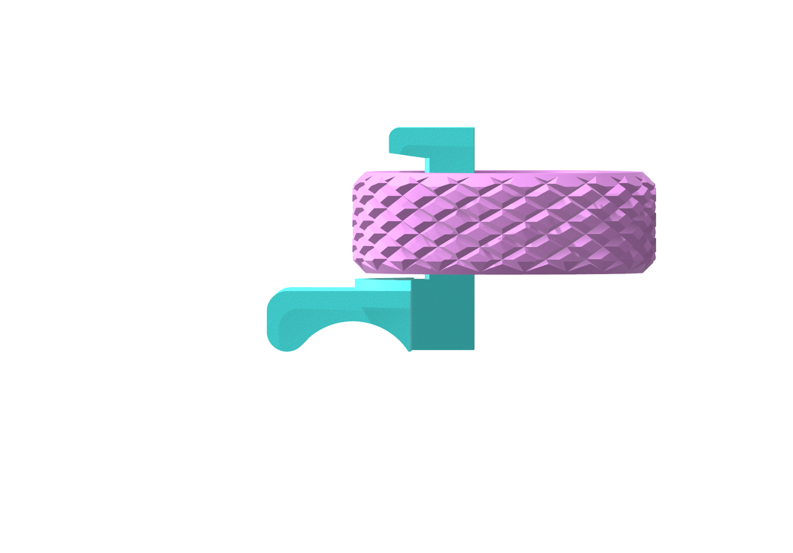

* 1. Slide the top clamp element into the channel, as shown in the image below.

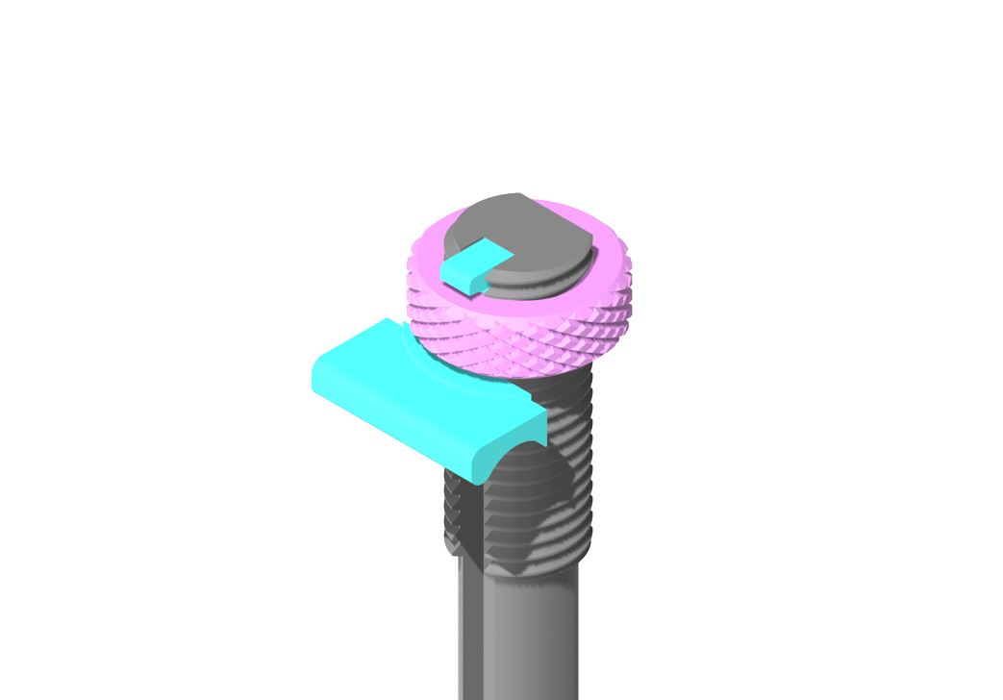

* 1. Turn the top nut clockwise to secure the top clamp to the screw as shown below.

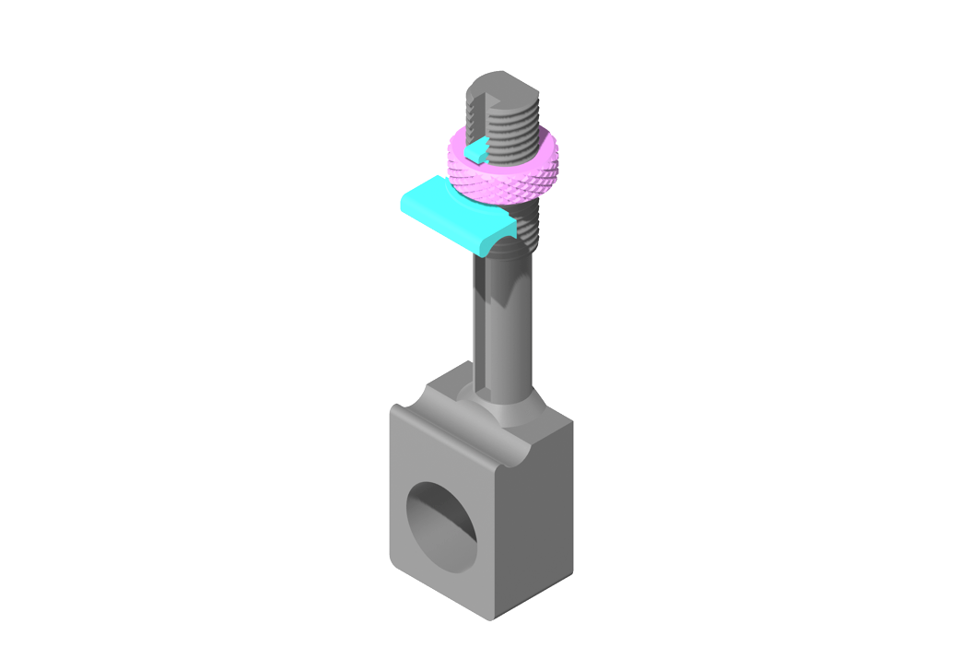

* 1. Collecting the 3D printed pieces for the grip, slide it onto the end of the PVC pipe.
  2. To finalise the rest of the antenna, slide the small plastic end caps onto each end of the tape measure.
  3. You should now have an antenna assembly that looks like the image below.

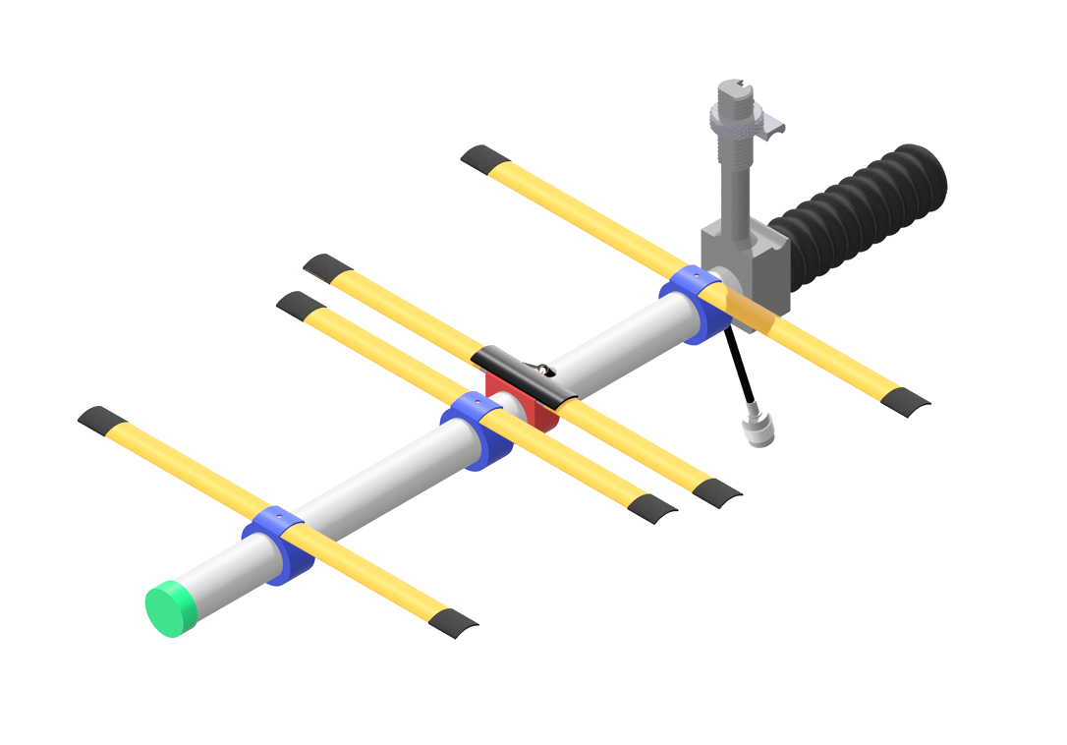

1. **Using the Antenna**
   1. To begin using the antenna, first turn off the Raspberry Pi and unplug ay power cables to make sure the LNA is off. Next, carefully unscrew the UHF connector from the original BinarX Antenna assembly.
   2. Warning: Incorrectly connecting and disconnecting radio connectors may damage or break the connectors. Note that the instructions on how to correctly connect the radio connectors for this step and any following connections are written on Pages 12-13.
   3. Place the BinarX-provided antenna aside and fold it closed carefully so that the connector does not get damaged.
   4. Install the UHF connector passing through the back of the antenna grip carefully.
   5. Place a phone running the Stellarium app into the phone holder and turn the nut clockwise until it is tight and the phone doesn’t move.
2. **Final Steps**
   1. Test your setup: After the physical assembly, run a test to make sure the antenna is connected to the SDR, and is receiving signals from satellites. You can use the SatNOGS client to schedule satellite passes.

Track Satellite Passes: Use the Stellarium app to predict satellite passes and manually. The antenna has been designed for a wide range of frequencies with lots of satellites, so you won’t need to tune anything!

1. **Packing it up**
   1. To pack up ground new antenna, first remove the small cap at the front.
   2. Next, remove the parasitic element tape measures and tape measure caps (the unsoldered ones), place them inside the tube and place the cap back on.
   3. Taking off the end caps of the driven element brackets, bend them around to the opposite side of the bracket and slide them into the holder.
   4. To reassemble the antenna, repeat steps 12a. to 12c in reverse!

**You’ve now finished the guide!**

HOW TO CORRECTLY CONNECT AN SMA/UHF CONNECTOR

SMA/UHF Connectors are very delicate and should be taken care of when connecting and disconnecting cables. To reduce the risk of damaging the connector, a mechanism was created on the connector to allow a secure connection to be made without causing the pin in the connector to rotate and risk scratching the port or bending inside.

To connect any SMA/UHF Male to SMA/UHF Female, first locate the ports of each. The Male connector has a small pin in the centre, whilst the female connector has a port for the pin, as shown below. This is not unique to SMA connectors and will be the same for a UHF.

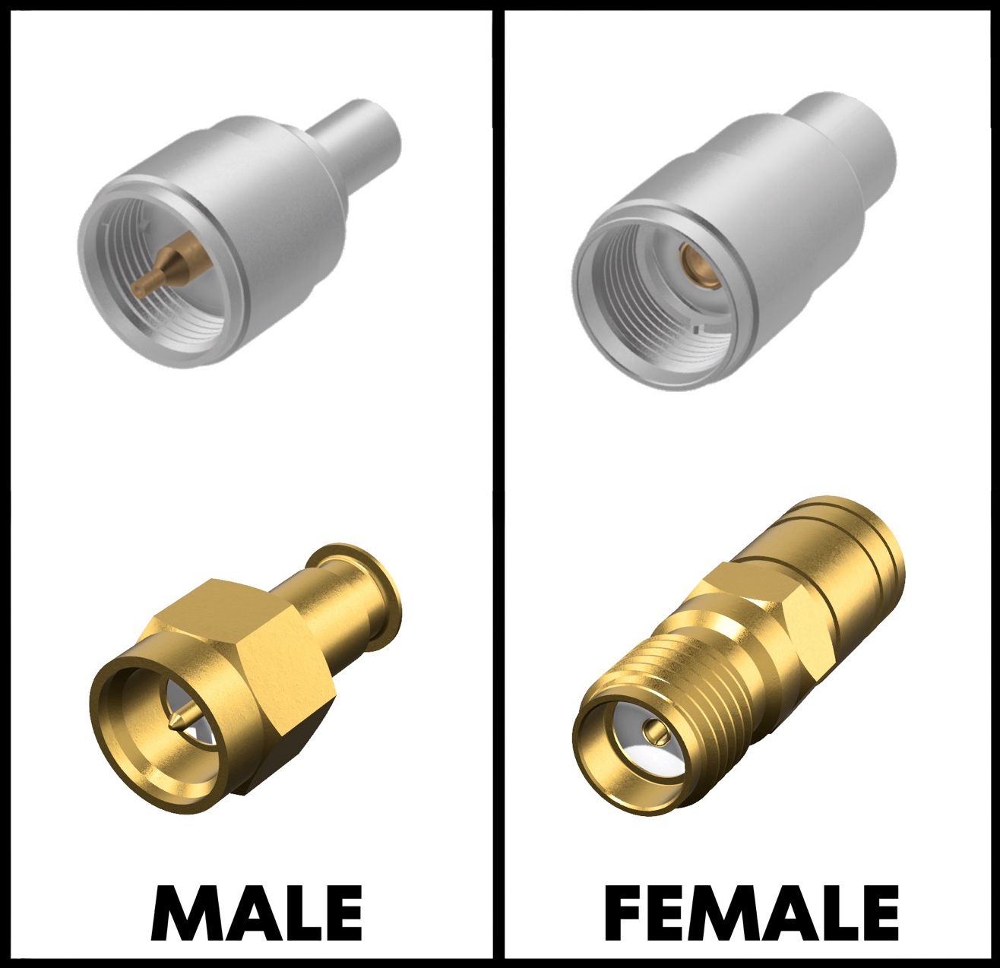

Once these have been found, gently line up the male connector with the female connector, making sure contact is made between the ports.

Keeping both ports still, rotate only the outer ring (highlighted in blue) on the Male connector, like hand tightening a screw, into the Female end to securely make an electrical connection.

